Name:___________________#_______
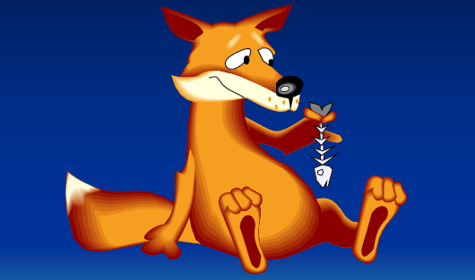
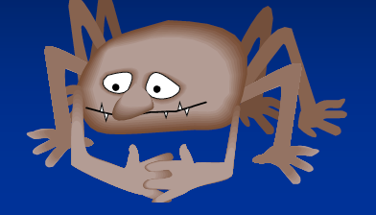
1. Use the Venn Diagram, to compare Aunt Fox from Aunt Fox and the Fried Fish to Spider in Hungry Spider.

Aunt Fox
Spider

2. Which character do you think was the most clever? Why?
________________________________________________________________________________________________________________________________________________________________________________________________________________________________________________________________________
3. Do you think the characters good reasons or bad reasons for playing tricks? Explain your answer.
________________________________________________________________________________________________________________________________________________________________________________________________________________________________________________________________________

4. How could the tricksters have solved their problems without playing a trick?
________________________________________________________________________________________________________________________________________________________________________________________________________________________________________________________________________

5. Who was your favorite trickster character? Why?
________________________________________________________________________________________________________________________________________________________________________________________________________________________________________________________________________

